AASHTO Innovation Initiative
[Proposed] Nomination of Innovation Ready for Implementation

Sponsor

Nominations must be submitted by an AASHTO member DOT willing to help promote the innovation. If selected, the sponsoring DOT will be asked to promote the innovation to other states by participating on a Lead States Team supported by the AASHTO Innovation Initiative.
1. Sponsoring DOT (State): Michigan DOT
2. Name and Title: Matthew J. Chynoweth, P.E.
Organization: Michigan Department of Transportation
Street Address: 425 W. Ottawa
City: Lansing
State: Michigan
Zip Code: 48909
Email: ChynowethM@michigan.gov
Phone: 517-243-4302
Fax: Click or tap here to enter text.

Innovation Description (10 points)

The term “innovation” may include processes, products, techniques, procedures, and practices.
3. Name of the innovation:
Steel Press-Brake-Formed Tub Girder (PBFTG)
4. Please describe the innovation.
PBFTG uses proven material and current design standards, combined with new fabrication and construction techniques, to produce a bridge superstructure with reduced maintenance cost, shortened construction time, and lengthens the service life over the current bridge superstructure baseline practice. PBFTG’s utilize a single steel plate that is strategically bent into a superior structural shape. The plate is cold formed into a U shape with a press brake, with each bend occurring along the plate’s longitudinal axis. The formed steel plate bend radius exceeds the minimum requirement, based on AISC and ASTM cold forming guidelines, and is designed for infinite fatigue life due to lack of connections and discontinuities. These fabrication advancements further lengthen the service life of the steel tub girder over current practice. Additionally, a hot-dipped galvanized coating can be applied to the PBFTG to further lengthen the maintenance free service life. By applying a Duplex coating, painting over hot-dip galvanized steel, and with appropriate composite concrete bridge deck detailing, PBFTG will meet the AASHTO Committee on Bridges and Structures strategic objectives of extending bridge service life to an anticipated 100 years.
5. What is the existing baseline practice that the innovation intends to replace/improve?
The current baseline practice is rolled steel I-beams, welded steel plate girders, or prestressed concrete beams.
6. What problems associated with the baseline practice does the innovation propose to solve?
Our environment is changing, and bridges across the United States are deteriorating at a rate which currently outpaces the available funding to slow our reverse deterioration rates.. It is estimated that it will take more than 80 years to fix all current structurally compromised bridges considering current federal and state capital investment levels. With service life as low as 35 years for the current baseline practice, the demand for newly constructed bridges will greatly exceed our future capacity.. In addition to to not meeting aspirational service life timeframes, each current baseline practice noted above has its own specific associated problem to solve. Rolled steel I beams and welded steel plate girders cannot efficiently provide the shallow span to depth ratios that are necessary to meet the new hydraulic needs of an increasingly demanding rainfall forecast and hydraulic flood models. Additionally, rolled steel I beams and welded steel plate girders become increasingly costly when reduced span to depth ratios are required. Prestressed concrete beams are a current baseline practice that meets these hydraulic requirements, however, prestressed concrete beams have a reduced service life in comparison with steel girder solutions. Prestressed concrete box beams often do not achieve the AASHTO 75 year design life in freeze-thaw environments, and do not have effective rehabilitation methods for repair at the end of their shorter service life.
7. Briefly describe the history of its development.
The press-brake-formed tub girder (PBFTG) was initially developed in 2004 in efforts consistent with FHWA’s Get-In, Get-Out, Stay-Out campaign for Accelerated Bridge Construction (ABC). In 2008 Michigan Department of Transportation authorized a research report under Contract No. 2002-0532 – Authorization 12, MSU APP 90038 (Report No. CEE-RR – 2008/01) and in 2010 a demonstration project on US-31BR in Whitehall, MI. Results from the research simulation studies and demonstration project indicated that the PBFTG are “a safe and viable system for short-span highway bridges.” Subsequently, the steel industry, through efforts of the Short Span Steel Bridge Alliance (SSSBA), also found that PBFTG where not only a viable system for short span highway bridges in the ABC market, but the overall bridge replacement market. PBFTG provide a new, cost effective manufacturing process for bridge girders that eliminates the fatigue critical details of a welded plate girders and provide a valuable tool in meeting today’s bridge needs. Over the following several years, the SSSBA followed up the MDOT research projects with a 7 Volume research report of its own, further standardizing PBFTG fabrication, design and details.
8. What resources—such as technical specifications, training materials, and user guides—have you developed to assist with the deployment effort? If appropriate, please attach or provide weblinks to reports, videos, photographs, diagrams, or other images illustrating the appearance or functionality of the innovation (if electronic, please provide a separate file). Please list your attachments or weblinks here.
Ohio DOT Industry Resources, Con-Struct Steel Press Brake Tub Girder Design Guidelines: http://www.dot.state.oh.us/Divisions/Engineering/Structures/Pages/Industry-Resources.aspx Research Report for MDOT under Contract No. 2002-0532 – Authorization 12, MSU APP 90038: Report No. CEE-RR – 2008/01 ”EVALUATION OF PREFABRICATED COMPOSITE STEEL BOX GIRDER SYSTEMS FOR RAPID BRIDGE CONSTRUCTION” SSSBA Research Report - Development and Feasibility Assessment of Shallow Press-Brake-Formed Steel Tub Girders for Short Span Bridge Applications: https://www.shortspansteelbridges.org/testing-of-press-brake-tub-girders/ Industry specific solution Valmont Structures Con-Struct Press-Brake-Formed Galvanized Steel Tub Girder Bridge System: http://www.constructbridge.com/
Attach photographs, diagrams, or other images here. If images are of larger resolution size, please provide as separate files.
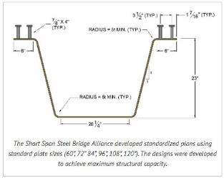 | 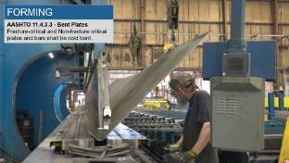 | 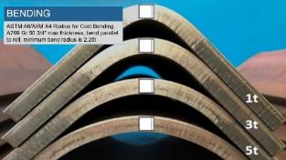
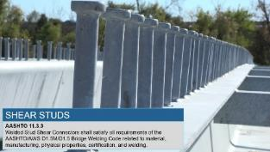 | 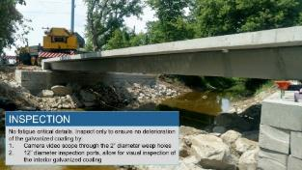 | 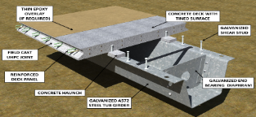
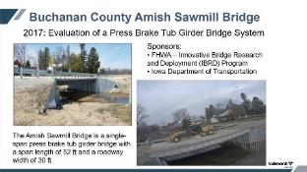 | 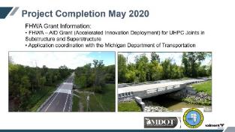 | 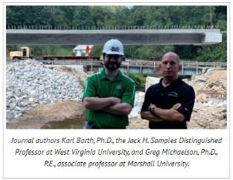

State of Development (40 points)

Innovations must be successfully deployed in at least one State DOT. The AII selection process will favor innovations that have advanced beyond the research stage, at least to the pilot deployment stage, and preferably into routine use.
9. How ready is this innovation for implementation in an operational environment? Please select from the following options. Please describe.
☐ Prototype is fully functional and yet to be piloted
☐ Prototype has been piloted successfully in an operational environment
☐ Technology has been deployed multiple times in an operational environment
☒ Technology is ready for full-scale implementation
PBFTG has been successfully installed in over 40 locations throughout the United States and Canada. Michigan DOT installed a demonstration project on US-31BR in 2010 and is still in place and in use. MDOT most recently has installations in St. Clair County, MI (2019) and is currently under construction on their 3rd application in Eaton County, MI. This product has also been approved by the Saskatchewan Ministry of Highways and installed in Colfax, SK.
10. What additional development is necessary to enable implementation of the innovation for routine use?
No additional development is necessary. AASHTO only needs to acknowledge the design and fabrication of press-brake-formed steel tub girders as a main load carrying steel girder.
11. Are other organizations using, currently developing, or have they shown interest in this innovation or of similar technology?? ☒ Yes ☐ No
If so, please list organization names and contacts. Please identify the source of this information.
Organization | Name | Phone | Email
Ohio DOT | Tim Keller, PE | 614.466.2463 | Tim.Keller@dot.ohio.gov
Buchanan County Bridge Department, IA | Brian Keierleber | 319-440-0268 | bkeierleber@co.buchanan.ia.us
St. Clair County Road Commission, MI | Bill Hazelton, PE | 810-388-4026 | whazelton@stclaircounty.org
Monroe County Road Commission, MI | Frank Westenkirchner, PE | 734-240-5101 | fwestenkirchner@mcrc-mi.org
Mercer County Bridge Department, PA | Bradley D. Elder, P.E. | 724-662-4977 (ext. 2492) | belder@mcc.co.mercer.pa.us
Champaign County Highway Department, IL | Jeff Blue | 217-384-3800 | jblue@co.champaign.il.us
Boone County Road Commission, MO | Darin Campbell | 573-875-8799 | Dcampbell@allstateconsultants.net
Eaton County Road Commission, MI | Frank J. Brechting III, MSCE, P.E. | 616-842-3361 | brechtingbridge@chartermi.net

Potential Payoff (30 points)

Payoff is defined as the combination of broad applicability and significant benefit or advantage over baseline practice.
12. How does the innovation meet customer or stakeholder needs in your State DOT or other organizations that have used it?
Press-Brake-Formed Steel Tub Girders (PBFTG) exceed service life of the current baseline practice and reduce overall life cycle cost. PBFTG reduce bridge superstructure installation duration, reducing user delay costs. PBFTG also reduce superstructure span to depth ratios, raising the low chord elevation and increasing hydraulic area beneath the bridge. PBFTG with a galvanized coating have up to 60 years of maintenance free service life, and with a painted Duplex coating over the galvanizing, this maintenance free service life can be increased to 100 years. PBFTG are sustainable as they are made from steel which has the highest recycling rate of any material. PBFTG can be galvanized to provide decades of maintenance-free longevity, and galvanizing’s primary component is zinc, natural, abundant, and 100% recyclable. Galvanized PBFTG is a sustainable and infinitely renewable building material
13. Identify the top three benefit types your DOT has realized from using this innovation. Describe the type and scale of benefits of using this innovation over baseline practice. Provide additional information, if available, using quantitative metrics, to describe the benefits.
Benefit Types | Please describe:
Cost Savings | PBFTG was recently bid against competing baseline practice products. Bids received were $75,000 for rolled steel I beams, $63,000 for Precast Concrete Box Culverts and $57,000 for PBFTG. Additionally, it has been shown by studies from SSSBA that current baseline practice steel bridges reduce life cycle costs as much as 10% in comparison with concrete bridges. PBFTG with a galvanized coating will have maintenance free service life that will further extend that of current practice. With similar up front construction costs as current practice, PBFTG will have a significant further reduction in life cycle costs.
Shorter Schedule | PBFTG with and integral precast concrete deck can be installed and opened to traffic in days, reducing road closures by months. This not only reduces construction costs, but also reduces user delay costs. For the same Cost Saving project where PBFTG was low bid, the bridge was “County Built” (installed with county labor) with only a 10 day road closure.
Environmental Benefits | PBFTG can achieve shallower span to depth ratios than current baseline practice. Shallow span to depth ratios are necessary to meet the hydraulic needs of an increasingly demanding rainfall forecast and hydraulic flood models. Current practice for steel girder options becomes increasingly costly when reduced span to depth ratios are required and prestressed concrete box beams often do not achieve the AASHTO 75 year design life in freeze-thaw environments. Additionally, galvanized PBFTG is a sustainable and infinitely renewable building material. Steel has the highest recycling rate of any material and galvanizing’s primary component is zinc which is natural, abundant, and 100% recyclable.

Provide any additional description, if necessary:
Click or tap here to enter text.
14 How broadly might this innovation be deployed for other applications in the transportation industry (including other disciplines of a DOT, other transportation modes, and private industry)?
PBFTG has been recently specified in the U.S. Army Corps of Engineers, Fort Worth District, Fort Wingate, NM Bridge 141 Replacement project (W9126G20U4083). PBFTG has already been used for land development projects in the private industry, with private owners such as the Brainerd International Raceway, CenterPoint Energy and Amazon. PBFTG can also be used by federal agencies such as the U.S. Department of Agriculture Forest Service and its quick deploy and simple installation would be ideal for the U.S. Customs and Border Protection horizontal border construction.

Market Readiness (20 points)

The AII selection process will favor innovations that can be adopted with a reasonable amount of effort and cost, commensurate with the payoff potential.
15. What specific actions would another organization need to take along each of the following dimensions to adopt this innovation?
Check boxes that apply | Dimensions | Please describe:
☒ | Gaining executive leadership support | Once PBFTG is recognized as a main load carrying member in AASHTO the only action an organization needs to adopt this innovation is to specify its use.
☐ | Communicating benefits | Click or tap here to enter text.
☐ | Overcoming funding constraints | Click or tap here to enter text.
☐ | Acquiring in-house capabilities | Click or tap here to enter text.
☐ | Addressing legal issues (if applicable) (e.g., liability and intellectual property) | Click or tap here to enter text.
☐ | Resolving conflicts with existing national/state regulations and standards | Click or tap here to enter text.
☐ | Other challenges | Click or tap here to enter text.

16. Please provide details of cost, effort, and length of time expended to deploy the innovation in your organization.
Cost: PBFTG was recently utilized for 2 MDOT local agency projects; 2020 letting JN 202455A bridge geometry of 38’ long by 35’-3” wide. Pay item Prefabricated Bridge Superstructure, Furn and Fab, low bid of $100,000 ($74.65/sft), average low bid price of $141,700 ($105.79 $/sft). 2019 letting JN 204206A bridge geometry of 50’ long by 37’-2” wide. Pay item Prefabricated Bridge Superstructure, Furn & Fab, low bid of $175,000 ($94.17/sft), average low bid price of $208,125 ($112.00 $/sft). These pay items include the fully fabricated and delivered PBFTG superstructure. The average bid square foot unit price for the prefabricated and furnished superstructure for both projects was $108.90/sft. The average unit price for both projects for the pay item Prefabricated Bridge Superstructure, Erect was $13.66/sft. This provides a total New Superstructure, Over Water unit cost of $122.56/sft. This price is 20% below current baseline practice pricing based on the MDOT LAP Bridge Cost Estimating Worksheet for New Superstructure, Over Water (not including demolition) of $154/sft.
Level of Effort: PBFTG Guidelines have been developed by the steel industry for ease of deployment. These guidelines included example AASHTO designs and standard details. PBFTG can be specified and fabricated by qualified steel fabricators.
Time: PBFTG fabrication is comparable to that of current baseline practice. PBFTG can be designed as a stand-alone bridge girder or as a prefabricated bridge superstructure. The prefabricated bridge superstructure option greatly reduces installation time and effort. Current baseline practice of for a typical superstructure replacement might be two months, while the prefabricated PBFTG system is two weeks.
17. To what extent might implementation of this innovation require the involvement of third parties, including vendors, contractors, and consultants? If so, please describe. List the type of expertise required for implementation.
The implementation of PBFTG will require the adoption of PBFTG design methodologies and fabrication specifications by AASHTO and DOT’s. Once adopted, Structural Engineering consultants can utilize AASHTO specifications and industry developed guidelines for design, detailing and specifications. Steel fabrication vendors with qualifying AISC certifications can supply PBFTG.

